<!--This file created 2:29 PM 10/29/97 by Claris Home Page version 2.0-->9.2 Project A
Automated Slope Fields

Computer algebra systems such as Maple, Mathematica and MATLAB provide extensive resources for the study of differential equations. For instance, the Maple command

with(DEtools):
DEplot( diff(y(x),x)=sin(x-y(x)), y(x),
x=-5..5, y=-5..5 );

and the Mathematica command

Needs["Graphics`PlotField`"]
PlotVectorField[{1, Sin[x-y]}, {x,-5,5}, {y,-5,5}]

produce direction fields similar to the one shown in Fig. 9.2.24 of the text.

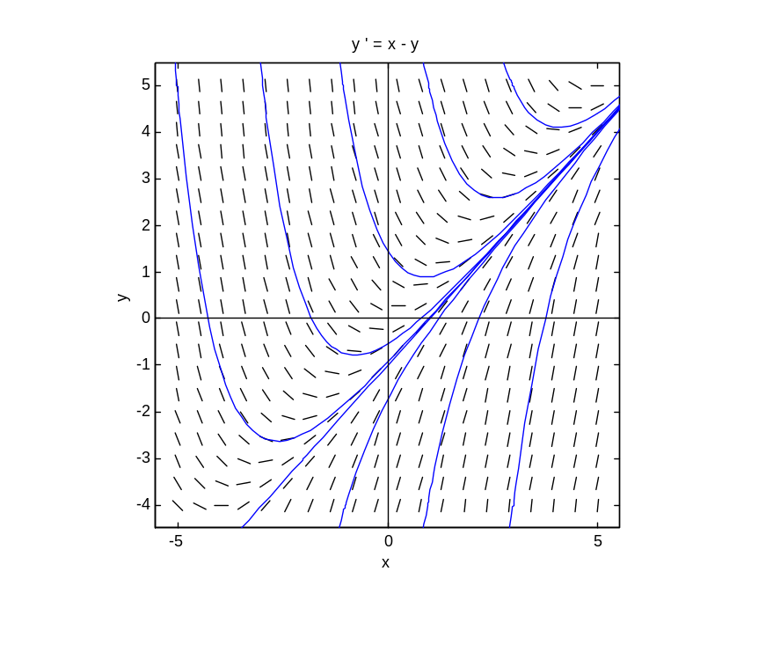
The figure above was generated by the MATLAB program dfield (John Polking and David Arnold, Ordinary Differential Equations Using MATLAB (2nd edition), Prentice Hall, 1999) that is available free for educational use. When a differential equation is entered in the dfield setup menu, you can immediately plot a direction field and then — with a single mouse click — plot also the solution curve through any desired point.

This figure shows a slope field and typical solution curves for the differential equation 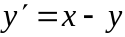. It appears that there exists a (single) straight line solution curve that all other solution curves approach as . Indeed, if we substitute the trial straight line solution 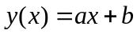 in the differential equation, we get

,

which is so if and only if a = 1 and b = –1. Thus 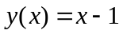 is, indeed, a straight line solution of the differential equation 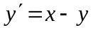. The figure then suggests (without proving it) that
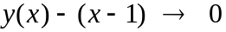 as .

The following two investigations involve similar inferences from slope fields and computer-generated solution curves. You might warm up by generating the direction fields and some solution curves for Problems 1-10 in this section.

Investigation 1
Plot a direction field and typical solution curves for the differential equation 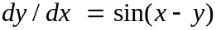, but with a larger window than that of Fig. 8.2.24 in the text. With 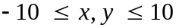, for instance, a number of apparent straight line solution curves should be visible.

(a) Substitute 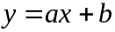 in the differential equation to determine what the coefficients a and b must be in order to get a solution.

(b) A computer algebra system gives the general solution

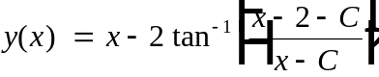.

Can you determine a value of the arbitrary constant C that yields the linear solution 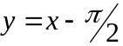 corresponding to the initial condition 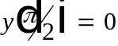?

Investigation 2
For your own personal differential equation, let n be the smallest integer in your student ID number that is greater than 1, and consider the differential equation

.

(a) First investigate (as in (a) above) the possibility of straight line solutions.

(b) Then generate a slope field for this differential equation, with the viewing window chosen so that you can picture some of these straight lines, plus a sufficient number of nonlinear solution curves that you can formulate a conjecture about what happens to y(x) as . State your inference as plainly as you can. Given the initial value y(0) = y₀, it would be nice to be able to say (perhaps in terms of y₀) how y(x) behaves as .

(c) A computer algebra system gives the general solution

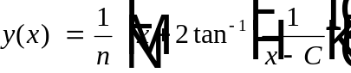

Can you make a connection between this symbolic solution and your graphically generated solution curves (straight lines or otherwise)?

In the sections that follow we outline the use of Maple, Mathematica, and MATLAB to generate slope fields and solution curves.

Using a Graphing Calculator

To plot a slope field and solution curves using a TI-89/92+ graphing calculator, we first select DIFF EQUATIONS in the MODE menu:

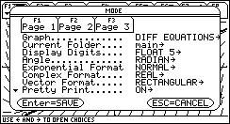

Then we enter our differential equation in the Y= editor, using t for the independent variable and y1 for the dependent variable:

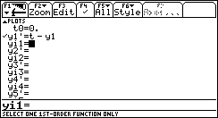

We then see a slope field when we display the GRAPH screen:

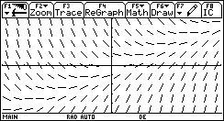

We can draw a solution curve by pressing 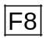 and entering the ty-coordinates of a desired initial point when prompted:

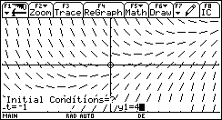

The desired solution curve is then plotted:

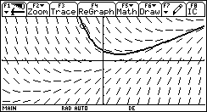

We can do this repeatedly to plot as many solution curves as we wish. Here we have used the initial points 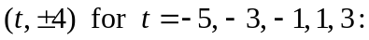

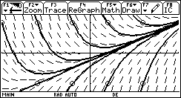
Using Maple

The differential equation dy/dx = x – y is defined in Maple by the command

de := diff( y(x), x) = x – y(x);

Note that we write y(x), not just y, to specify that the dependent variable y is a function of the independent variable x, and that := is used as the assignment operator. The differential equation solver in Maple is dsolve, and it gives the general solution

yg := dsolve( de, y(x) );

Observe how Maple writes the (first) arbitrary constant _C1 that appears. We can verify that the righthand side expression in the equation yg actually satisfies the differential equation by showing that it yields an identity upon substitution.

subs( y(x) = rhs(yg), de );

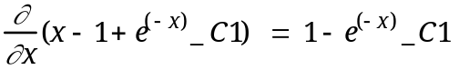

When we enter the command eval(%) to ask that the derivative on the left be evaluated, the identity

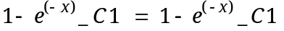

that results shows that the general solution of the differential equation de is, indeed, y(x) = x – 1 + Cex. We can get a particular solution satisfying a given initial condition either by specifying it in the dsolve command,

y1 := dsolve( {de, y(0)=2}, y(x) );

or by substituting a specific numerical value for the arbitrary constant in the general solution:

y2 := subs(_C1=0, yg );

We can plot both these solution curves simultaneously:

y1 := rhs(y1):
y2 := rhs(y2):
plot( {y1,y2}, x=-1..3 );

The result is shown at the top of page 5.

Any finite number of particular solutions could be plotted simultaneously (as shown in the figure at the top of page 5) by entering them as a set enclosed by braces. However, the DEtools package contains the special command DEplot for doing this sort of thing. The following rather detailed command shows how to plot simultaneously a slope field and a collection of solution curves satisfying a set of separate initial conditions, each corresponding to a different initial point (x₀, y₀).

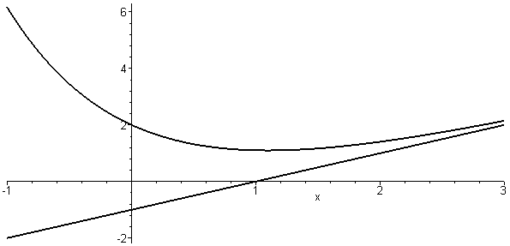

with(DEtools):
DEplot( diff(y(x),x) = x - y(x),y(x),
x=-5..5, y=-5..5,
{[0,4],[0,2],[0,1],[0,0],[0 ,-1],[0,-2],
[0,-4],[-4,-2],[-3,4],[-4,4],[1,4],[2,4],
[3,4],[-2,-4],[1,-4],[2,-4],[3,-4]},
dirgrid=[12,12],
color = black, linecolor = blue,
thickness = 2 );

We have specified the right hand side f(x, y) = x – y of the differential equation
y' = f(x, y), the axes [x, y] for plotting, and the window to be plotted.

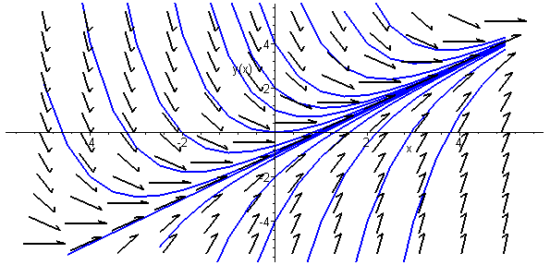

Here we see a pleasant variety of solution curves — all appearing to funnel in on the single linear "asymptotic solution" y = x + 1 — together with a slope field consisting of a 12-by-12 grid of arrows. We could plot the slope field alone by deleting the initial points.

Using Mathematica

To define the differential equation y' = x – y in Mathematica we enter the command

de = D[y[x],x] == x - y[x]

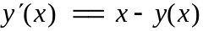

Note that Mathematica uses = for assignment, == for ordinary equality, and square brackets for functional notation. The differential equation solver in Mathematica is DSolve.

soln = DSolve[ de, y[x], x ]

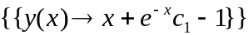

We can define the general solution explicitly as a function of x by taking the 2nd element of the 1st element of the 1st element of the nested list soln:

yg[x_] = soln[[1,1,2]]

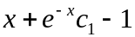

We can verify this general solution by substituting it for the function y in the differential equation.

de /. y -> yg

True

We can get a particular solution satisfying a given initial condition by specifying it in the DSolve command:

y1 = DSolve[{de, y[0] == 2}, y[x], x];
y1 = y1[[1,1,2]] // Simplify

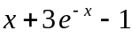

Alternatively, we can substitute a numerical value for the arbitrary constant in the general solution:

y2 = yg[x] /. C[1] -> 0

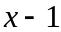

We can plot both these solution curves simultaneously; the command

Plot[ {y1,y2}, {x, -1,3} ];

produces the same two-curve figure generated previously using Maple. Indeed, any finite number of particular solutions could be plotted simultaneously by entering them as a list enclosed by braces. We can construct just such a list by substituting a list (or table) of numerical values for the arbitrary constant C[1] = c₁ in our general solution.

yp = yg[x] /. C[1] -> Table[c, {c,-5,5} ]

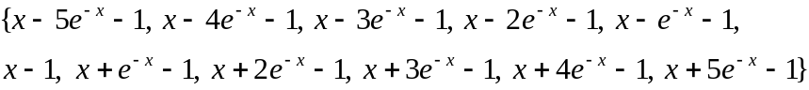

Here we have specified the values C[1] = –5,–4, ....., 4,5.

curves =
Plot[ Evaluate[yp], {x,-5,5}, PlotRange -> {-5,5}];
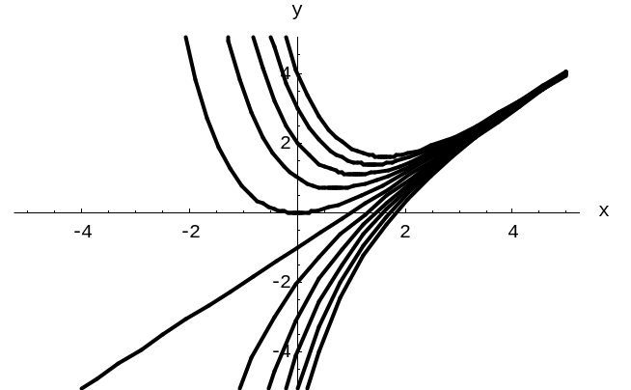

Here we see a family of solution curves, all appearing to funnel in on the single "asymptotic solution" y = x + 1. We can use the PlotVectorField function, after loading the Mathematica package

Needs["Graphics`PlotField`"]

to superimpose a slope field. Then the commands

slopes =
PlotVectorField[{1,x-y}, {x,-5,5}, {y,-5,5} ];

Show[ curves, slopes, AspectRatio -> 1 ];

do the job; try it for yourself.

Using MATLAB

Figures including slope fields are generated with the greatest ease using the menu-driven dfield function in the ODE Using MATLAB package mentioned previously. Here we illustrate also the "hands on" generation of symbolic solutions and solution curves using the Student Edition of MATLAB (version 5) — or the professional edition equipped with the Symbolic Math Toolbox, which calls on an imbedded Maple kernel for the execution of symbolic operations.

Symbolic variables, formulas, or equations are entered as strings enclosed in single quotes. Thus we can define the differential equation y' = x – y by entering

syms x y
de = 'Dy = x - y'

de =
Dy = x - y

with D denoting differentiation of the dependent variable y (which immediately follows the D) with respect to the independent variable x (the other variable in the equation). The function dsolve computes explicit symbolic solutions (when possible). Thus:

yg = dsolve(de,'x');
yg = expand(yg)

yg =
x-1+1/exp(x)*C1

Apparently we have a general solution involving an arbitrary constant C1. To verify this, we check that when we differentiate the expression yg with respect to the symbolic variable x,

Dy = diff(yg,x)

Dy =
1-1/exp(x)*C1

We get the same result as when we substitute yg for y in the differential equation,

subs(de, y, yg)

ans =
Dy = 1-1/exp(x)*C1

[The syntax for symbolic substitution of new for old in the expression expr is subs(expr, old, new).]

We can get a particular solution satisfying a given initial condition either by specifying it in the dsolve command,

y1 = dsolve(de, 'y(0)=2', 'x');
y1 = expand(y1)

y1 =
x-1+3/exp(x)

or by substituting a specific numerical value for the arbitrary constant in the general solution:

y2 = subs(yg,'C1',0)

y2 =
x-1

We can use MATLAB's ezplot command to plot both these two solution curves with the commands

ezplot(y1,[-1 3])
hold on
ezplot(y2,[-1 3])
axis([-1 3 -2 6])
grid on
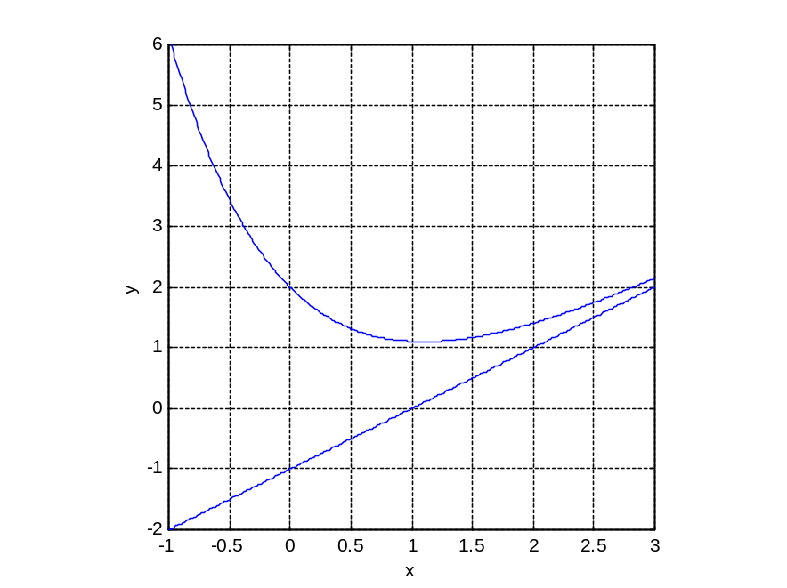

The command ezplot('f', [a b]) plots the expression 'f' as a function of x on the interval [a, b]. The hold on command holds the first solution curve in place while the while the second one is plotted. The axis command overrides MATLAB's auto-sizing and shows the picture in the desired viewing window:

Unless the special purpose dfield program is used, plotting slope fields in MATLAB requiries a bit of work. The following program utilizes the built-in command quiver(x,y,dx,dy) that plots an n × n array of vectors with x- and y- components specified by the n × n matrices dx and dy, based at the xy-points in the plane whose x- and y- coordinates are specified by the n × n matrices x and y.

% slope field program sfield.m
n = 10; % no of subintervals
a = -5; b = 5; % x-interval
c = -5; d = 5; % y-interval
h = (b-a)/n; k = (d-c)/n; % x- and y-step sizes
x = a : h : b; % x-subdivision points
y = c : k : d; % y-subdivision points
[x,y] = meshgrid(x,y); % grid of points
f = x - y; % define f(x,y)
t = atan(f); % angle of inclination
dx = cos(t); dy = sin(t); % xy-components of arrow
quiver(x,y,dx,dy) % plot slope field
axis([a b c d]) % viewing window
grid on % draw grid lines

However, you need not be concerned about these matrices of coordinates and components — only the number n of subintervals in each direction, the desired viewing window a ≤ b, c ≤ d, and the expression f defining the right-hand side of the differential equation need be altered when the program sfield is defined by saving the commands listed above in the text file sfield.m. (Alternatively, these commands could be entered individually in command mode). For instance, once the slope field program sfield has been defined, the commands

for k = -5 : 5
ezplot(subs(yg,'C1',k),[-5 5]);
hold on
end
sfield

first plot the particular solution curves corresponding to the values –5, –4, ....., 4, 5 of the arbitrary constant C1 in the general solution yg, and then a 10 × 10 grid of direction field arrows is added.
